TRO Data Refresh Training Guide
Step 1: Open TRO Not Served Reports – Biannual Runs, located in DARS V Drive, in the Family Folder
File Path: V:\Family\TRO Not Served Reports - Biannual Runs\2025_July_Run
- Go to DARS drive. Click to open the Family folder.
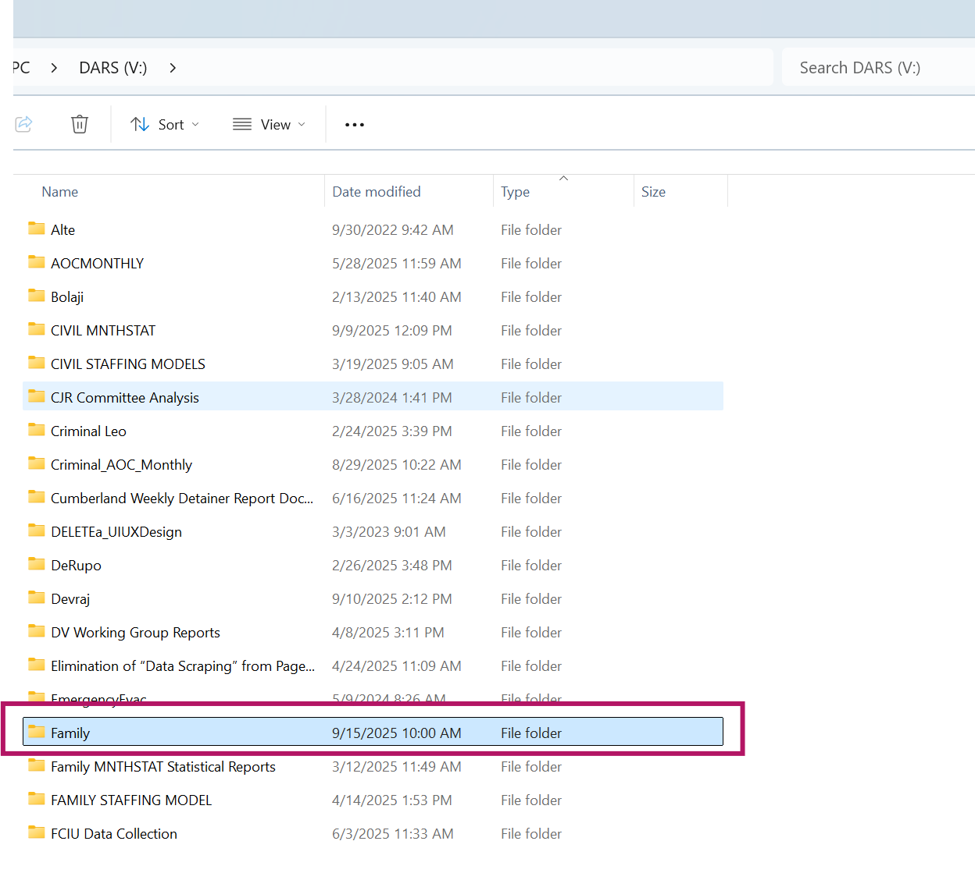
- In the Family folder, click to open the TRO Not Served Reports – Biannual Runs
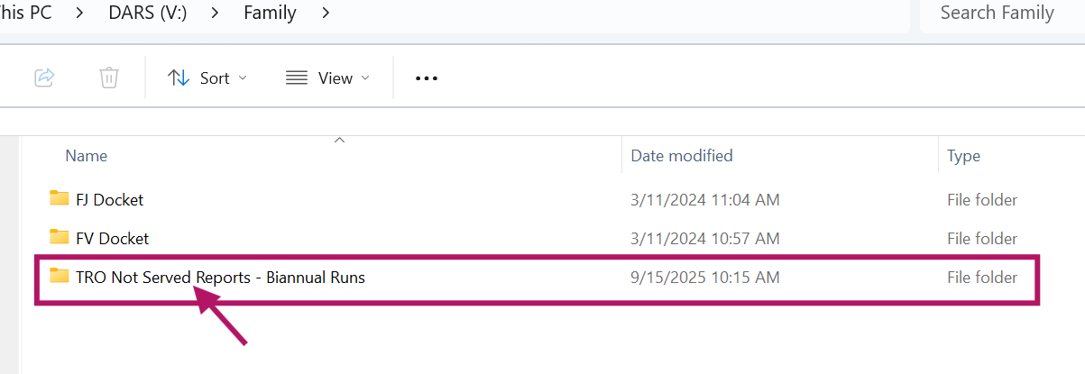
- Locate the folder where the generated reports will be stored (according to their run date). Upload all county files here.
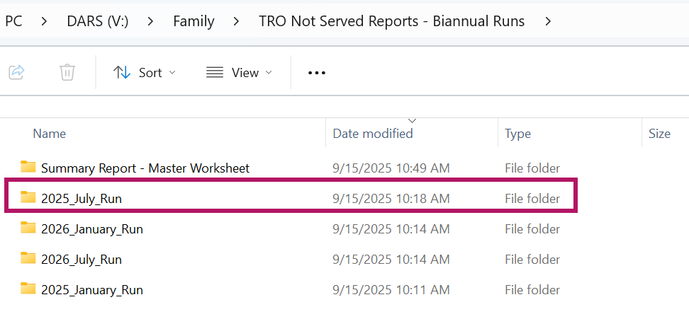
- When uploaded, it should look like this:
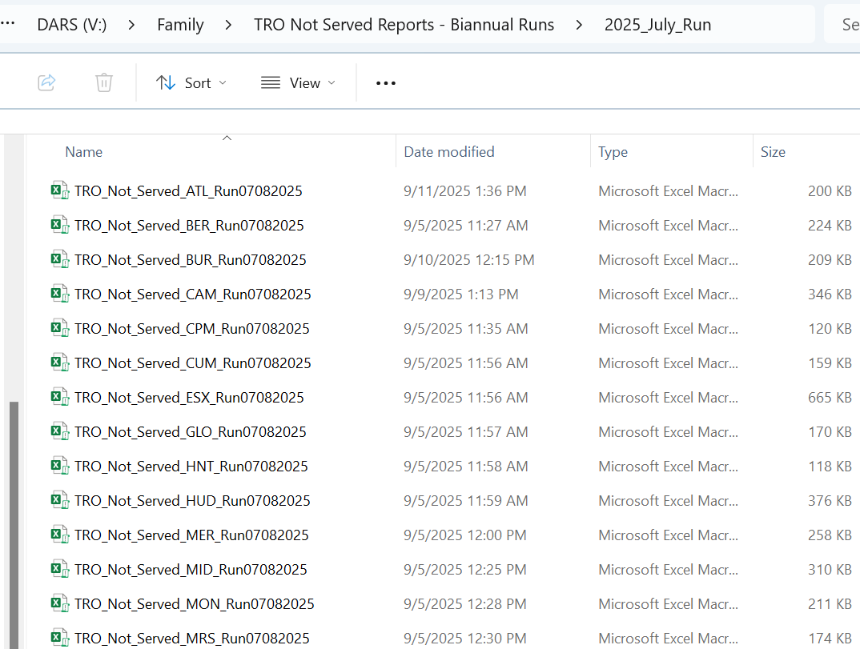

Step 2: Find the Data Tab
What to do:
- Look at the ribbon at the top of Excel
- Find and click the "Data" tab
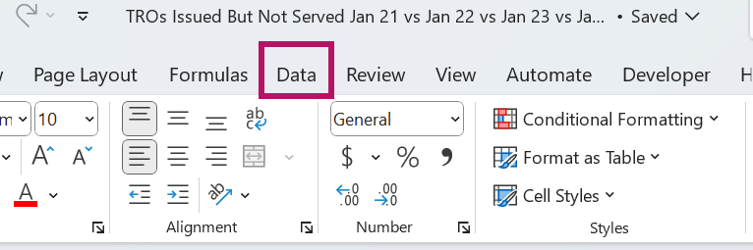
Location:
- Top of screen in the ribbon
- Usually the 6th tab from the left
- Between "Formulas" and "Review"
Step 3: Click "Refresh All"
What to do:
- In the Data tab, find "Refresh All" button
- Click it once
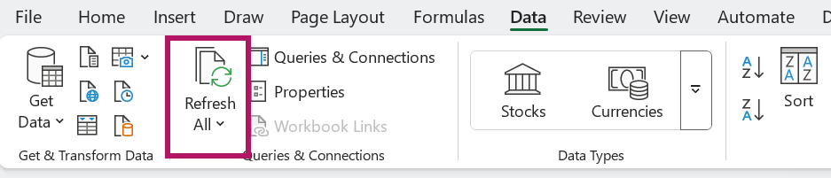
Location:
- Left side of the Data tab ribbon
- Large button with refresh arrows icon
- Next to "Get Data" dropdown
Step 4: Wait for Processing
What to do:
- Do NOT click anything else
- Watch for the progress indicator
- Wait until processing completes
│ Bottom of Excel window: │
│ 🔄 Loading data... Please wait │ ← You'll see this
What happens:
- Excel will show "Loading data..." at the bottom
- May take 30-60 seconds
- Screen might flicker briefly
- This is normal - don't worry
Step 5: Check the current run date (e.g. July 8, 2025) rows in the ‘Table 1’ worksheet of the Summary Report
What to do:
- Look for "July 8, 2025" in column B
- Check that numbers appear in the 2025, 2024, 2023 columns
- Verify multiple counties have data
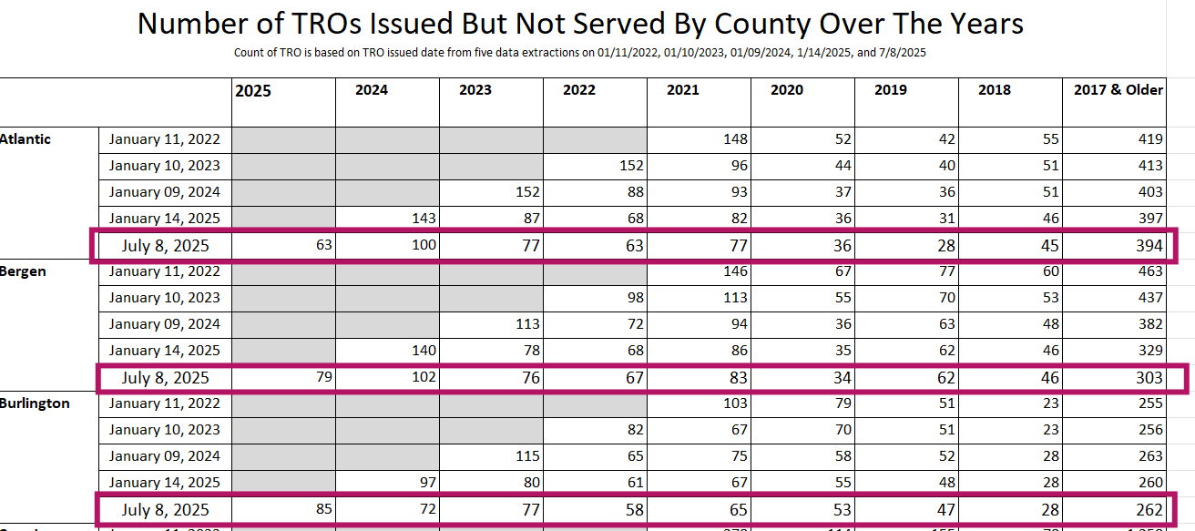
What to verify:
- Numbers are present (not blank)
- Multiple counties show current run date (e.g. July 8, 2025) data
- Totals at bottom have updated
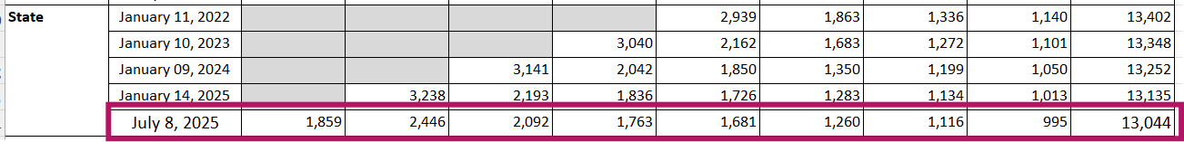
Step 6: Save the file
What to do:
- Press Ctrl + S on keyboard
- OR click the save icon in top-left corner
Step 7: Verify Your Results
What to do:
- Scroll through the report
- Check that statewide totals look reasonable
- Compare to previous reports if needed
What success looks like:
- All July 8, 2025 rows have numbers
- Totals appear in the bottom summary rows
- No error messages visible
- Numbers seem consistent with expectations

Quick Reference Card
Copy this and keep it handy:
1. Open TRO file
2. Click Data tab
3. Click Refresh All
4. Wait for completion
5. Check current run date (e.g. July 8, 2025) rows have numbers
6. Save with Ctrl + S
7. Contact Keisha Bolaji, DARS, if any problems persists.
Emergency Contact: Keisha Bolaji – Keisha.Bolaji@NJCourts.gov

